Althea Ricci D.G. Ramirez April 25, 2023

9 Sapphire Seatwork#1

**Quiz Mansion**

**GITHUB LINK:** <https://ricciricciricci.github.io/FV_ICT9S_Q4SW1_Ramirez/FV_ICT9S_Q4SW1_Ramirez.html>

<https://github.com/ricciricciricci/FV_ICT9S_Q4SW1_Ramirez.git>

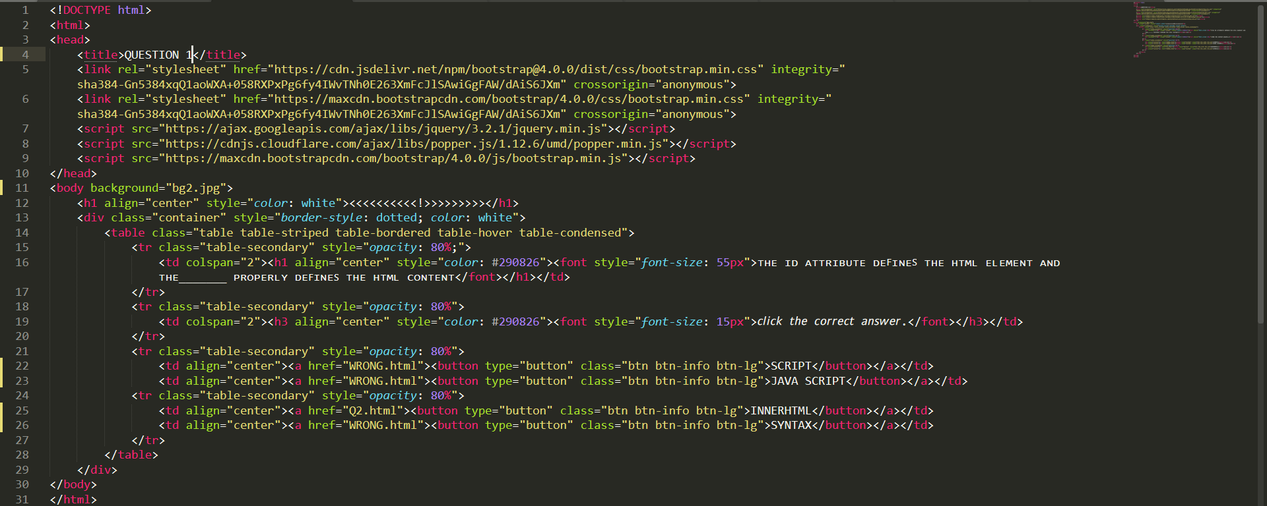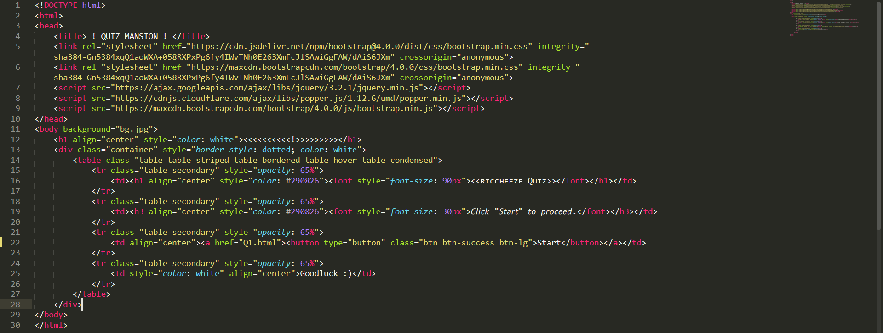

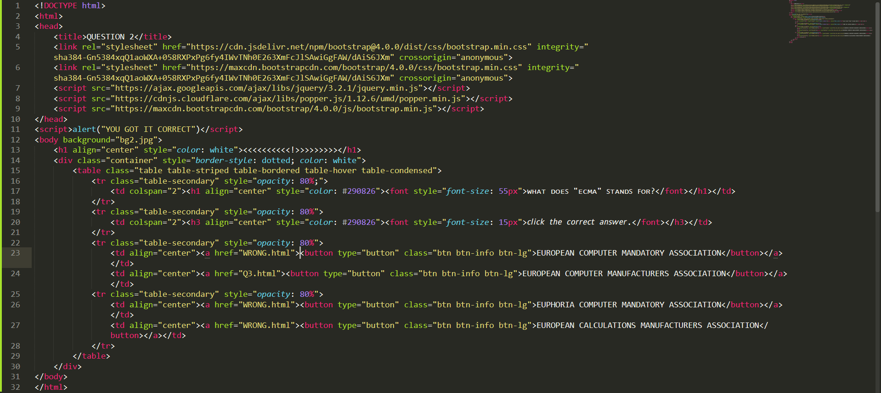

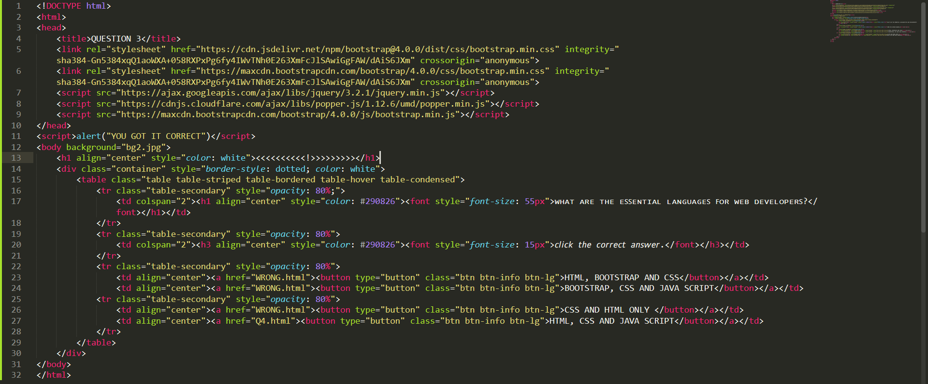

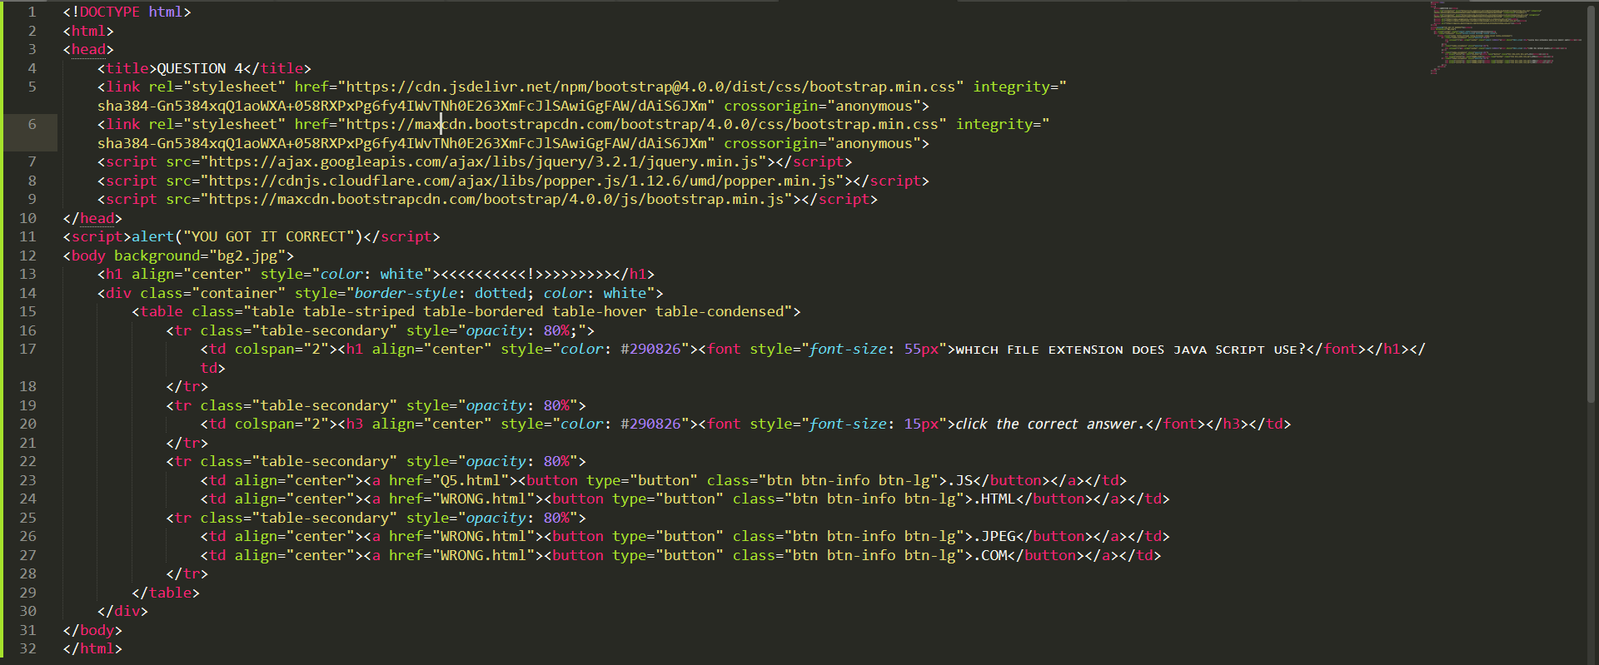

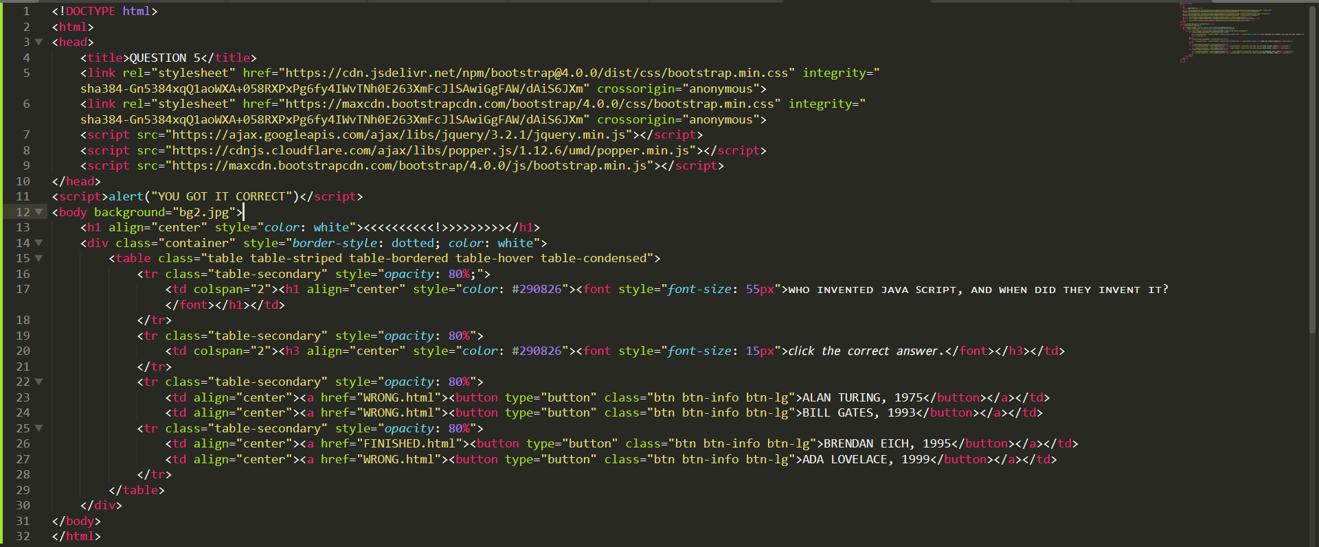

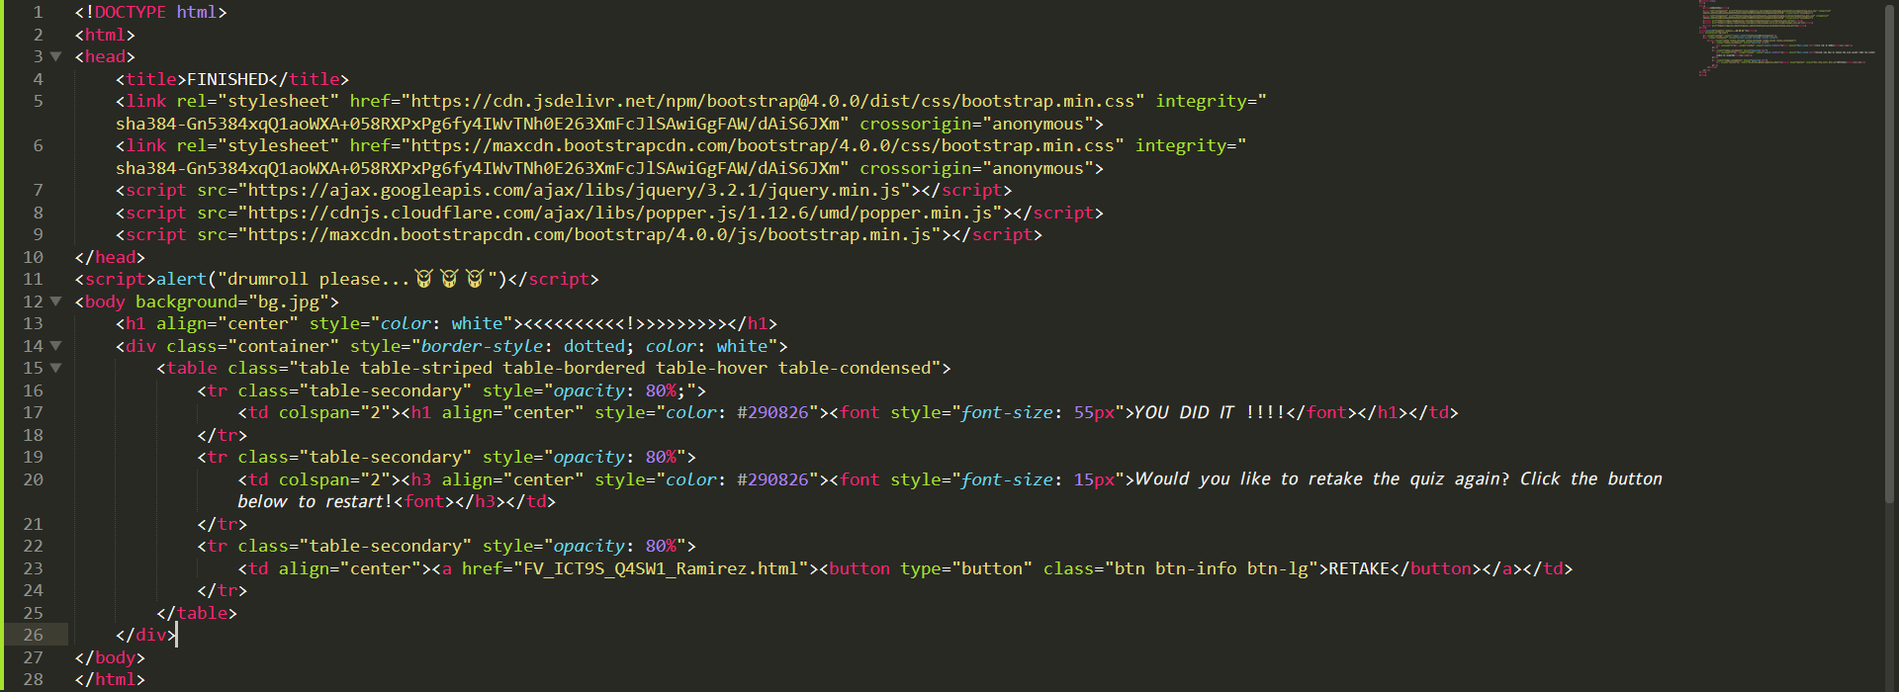

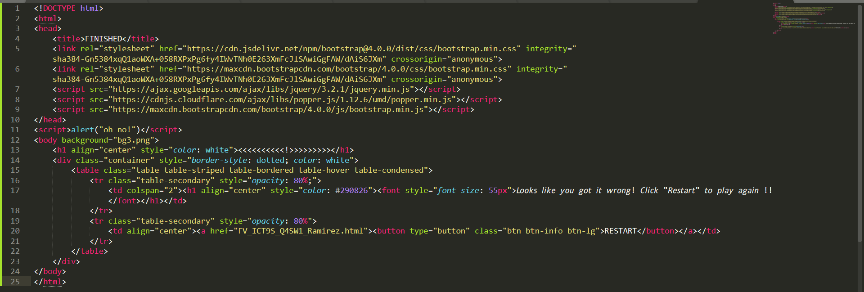



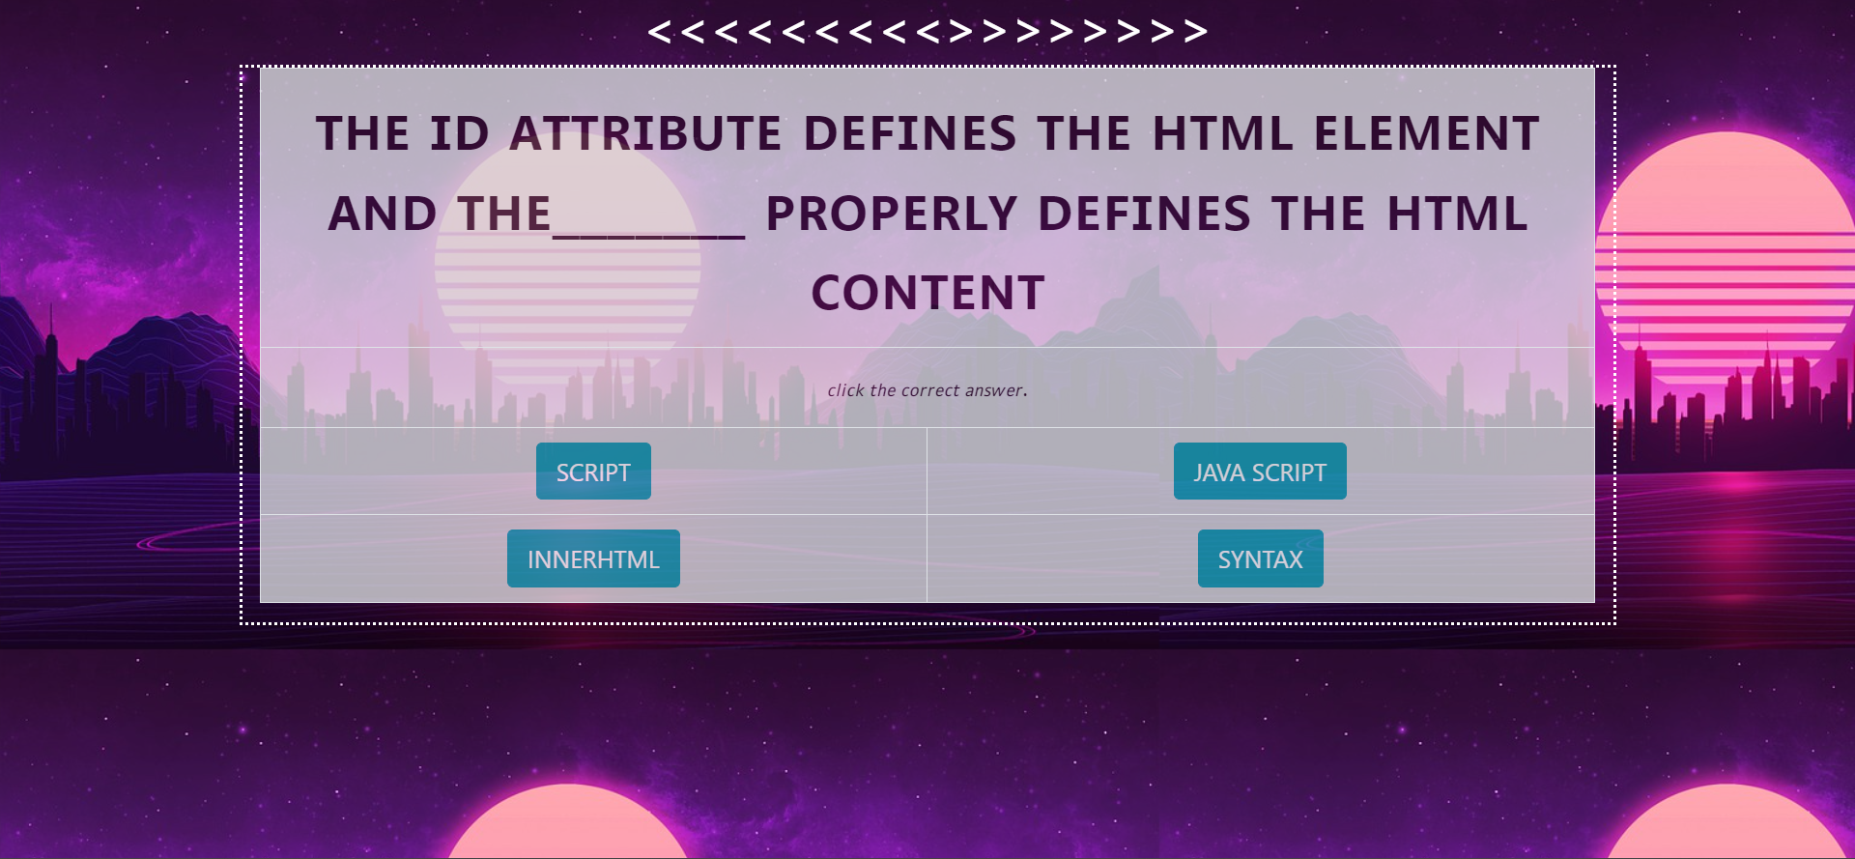

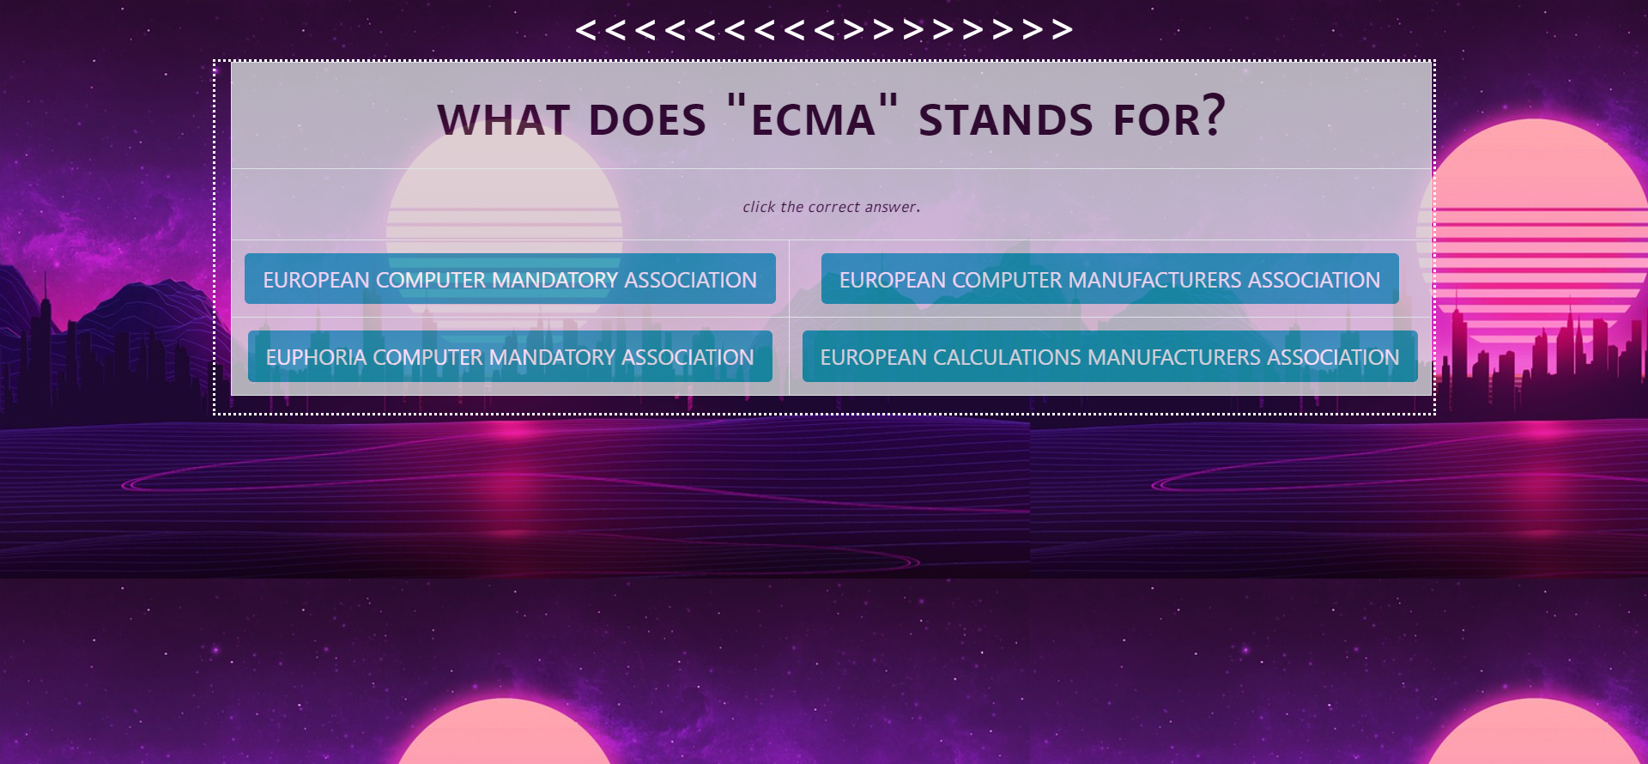

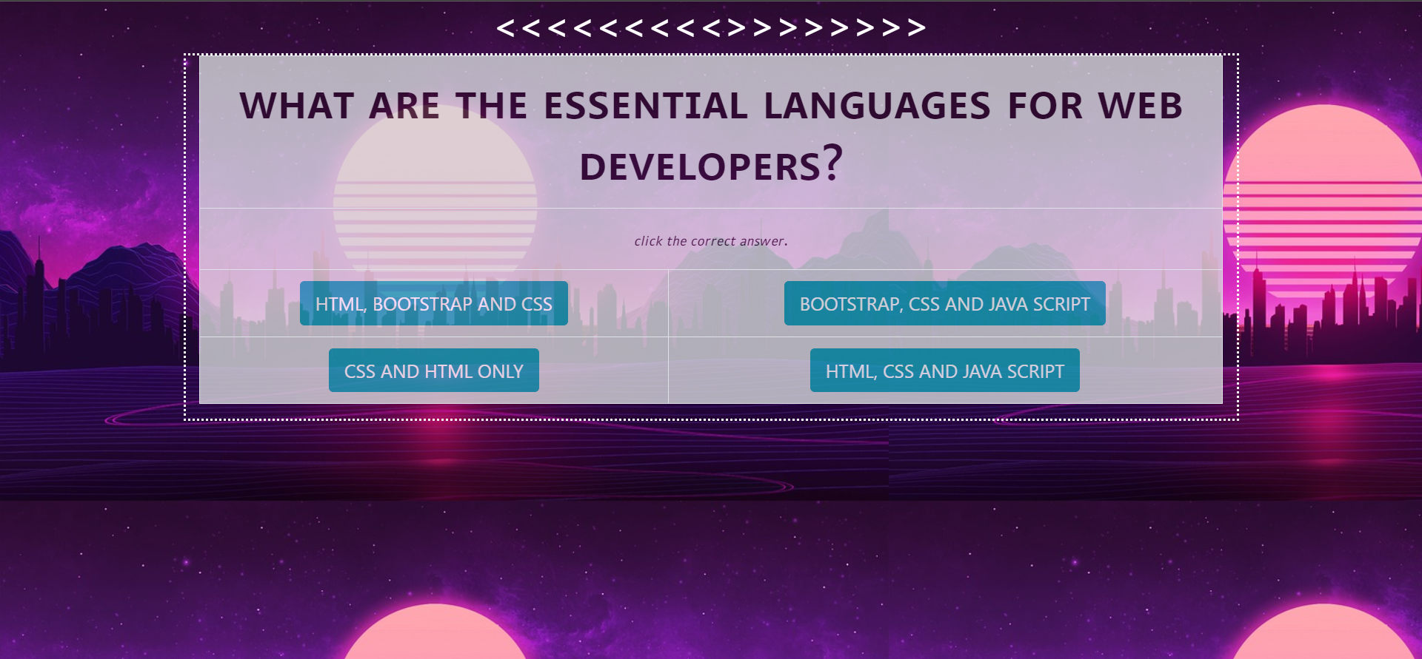

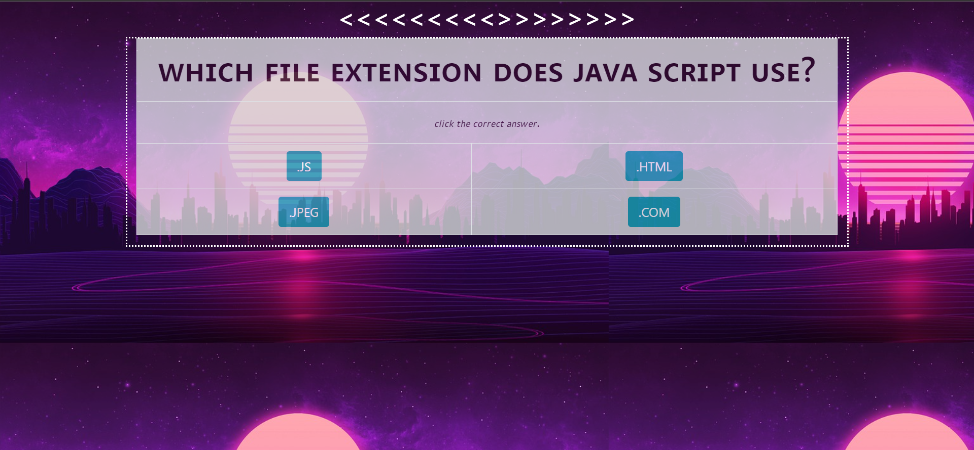

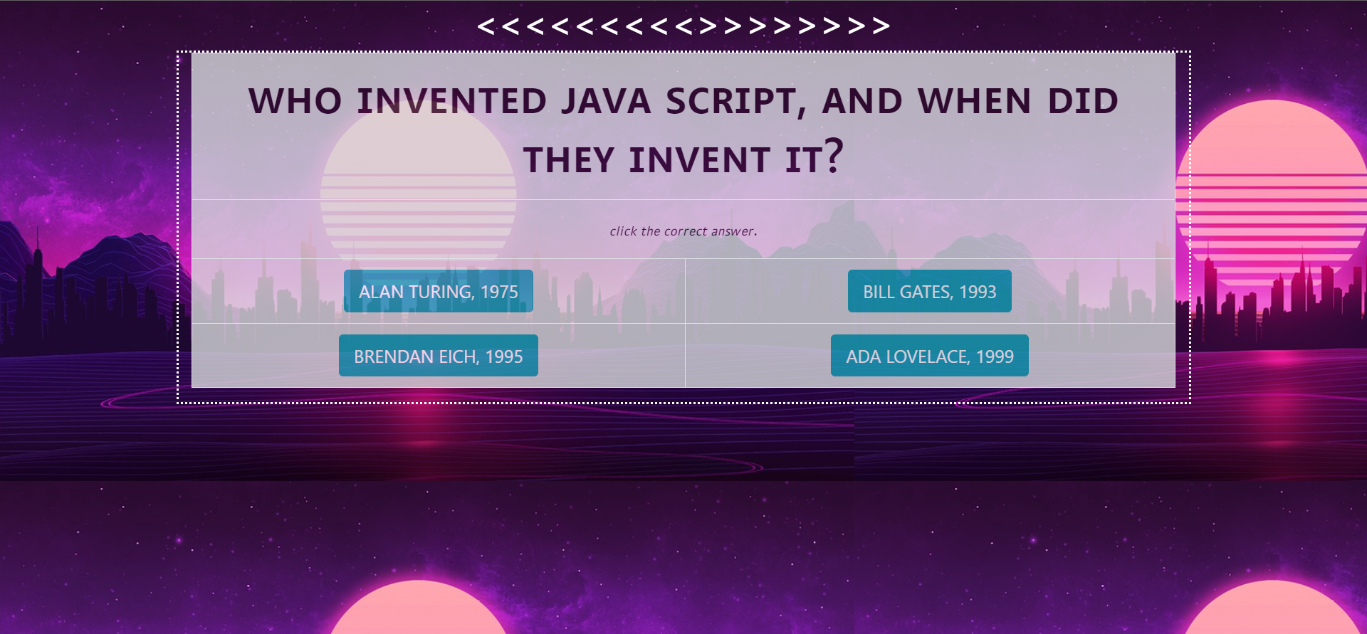

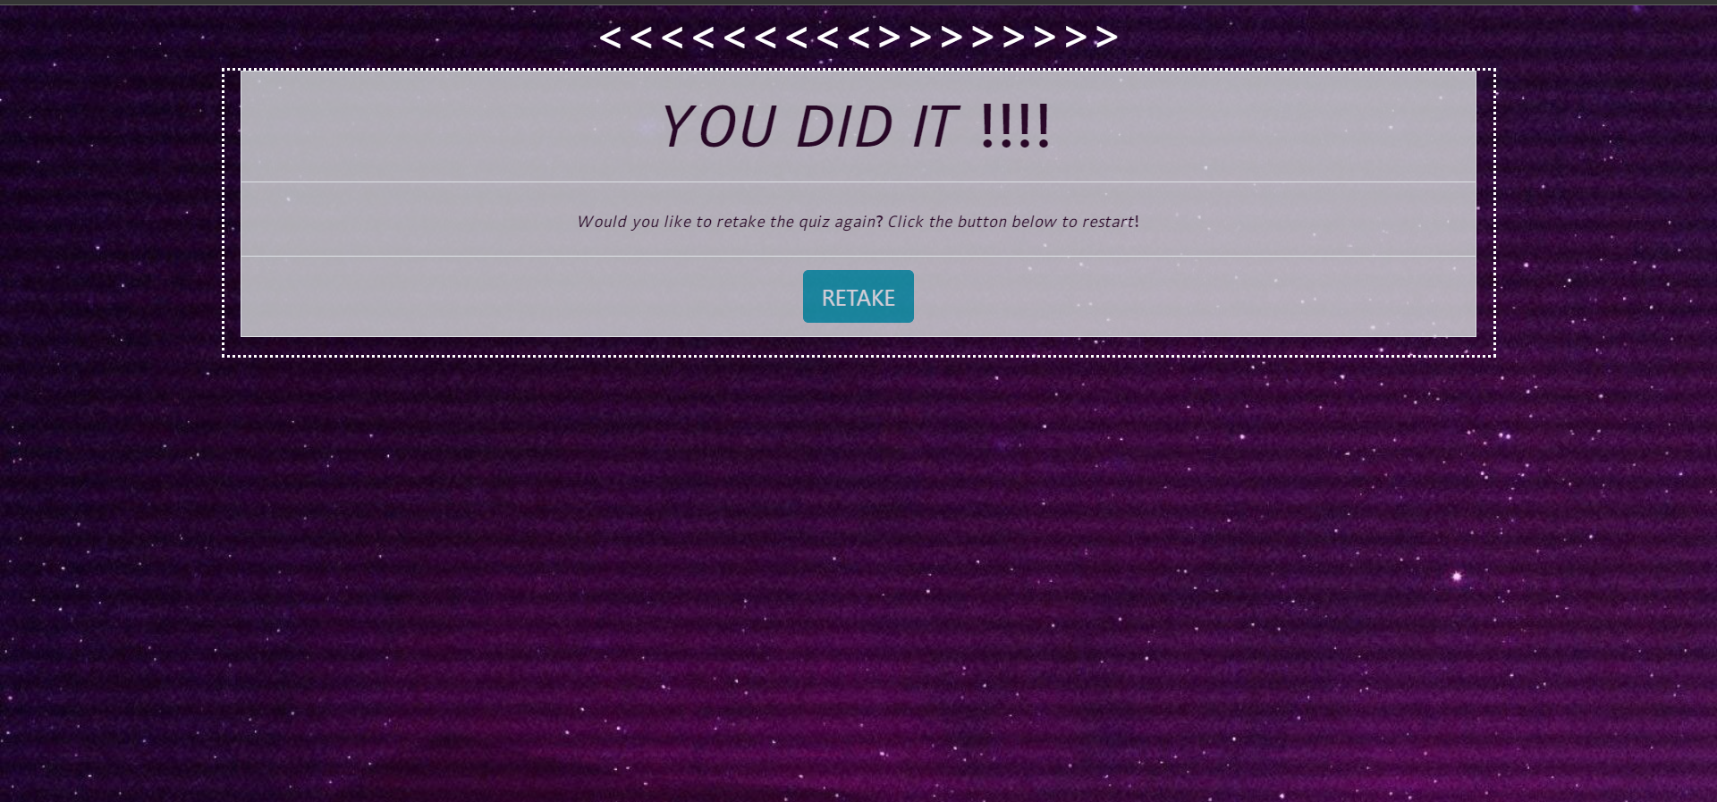



**Sources:**

<https://pixabay.com/illustrations/city-sunset-night-landscape-urban-5848267/>

<https://pixabay.com/illustrations/city-sunset-night-landscape-urban-5848267/>